In this tutorial I will be showing you how to set up an animation and then trigger it with an object in game

1. First set up a plane as flooring through GameObject 🡪 3D Object 🡪 Plane
2. Now create a cube with GameObject 🡪 3D Object 🡪 Cube. This object will be the object that we animate, you should transform this object into a rectangle with the scale tool on the top left, also rename the object to make it easier to find I renamed mine “Animation Object” your scene should look something like this now 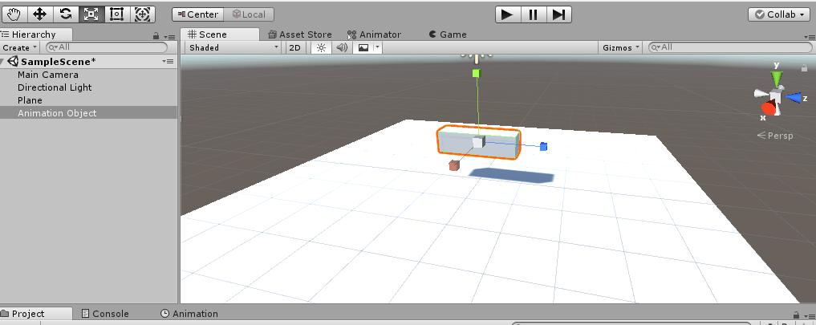
3. Now what we want to do is set up the animation that will play, this animation will be simply as I will just have the object rotate in place. First we need to open up two new windows, Animation and Animator, if you do not have these windows open already Go to Window 🡪 Animation 🡪 Animation/Animator be sure to have both open
4. Now move both of these windows somewhere that it won’t bother you and you can still see the scene, you can do this by clicking and dragging the windows someplace else.
5. Click on the Object you wish to animate, in this case for me it’s “Animation Object” with the object selected go into he Animation window and click on “**create**” it will ask to save a file simply rename the file to something suitable such as “Rotation” and save it, the animation window will now look different.
6. With the object Selected click on the red record button in the animation tab it will now record what will happen to the object, the starting keyframe of the object should already be set to default so move the white line further down by clicking on it. (an example picture can be seen bellow) 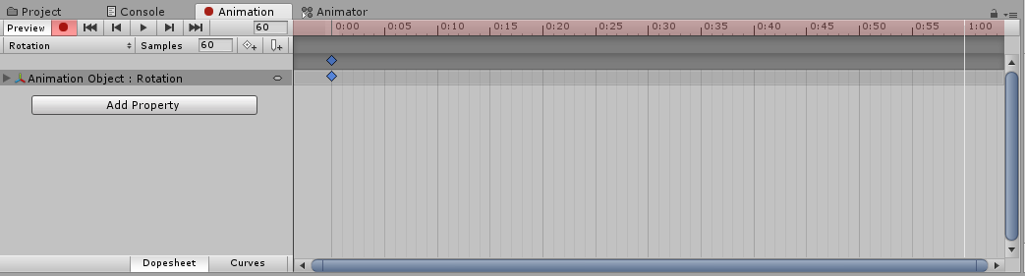
7. Now with the new time selected you can either rotate the object manually or go into he inspector and change the rotation of Y to 180 by changing this it will create a new keyframe in the animation. Now press on the recording button again to stop and then click on the play button to test your animation the object should turn 180 degrees and then loop thus rotating the object indefinitely you have now completed the animation and now we just have to have it be triggered by something
8. Now we will quickly create an GameObject that will trigger our animation, simply create a new 3D object Gameobject 🡪 3D Object 🡪 Cube Move it somewhere appropriate and then add the component “RigidBody” to the cube after this be sure to tag the cube as player in the inspector
9. With the animation object selected go into the animator window if you start the game you should see that it goes from Entry 🡪 to rotation when you start, we want it to not start until it is triggered so right click and create an empty state by going Create state 🡪 Empty after creating this state right click on this empty state and press on “Set as default layer” Now it goes from entry too the empty state and the animation will not play.
10. Now to make a script that will allow us to play the animation click on the animation object and create component, type in “Animation” nothing will show up so select “New script” the name animation should be set already for the script so simply press on create and add to make the new script.
11. Open up your script and add in the code bellow, the notes explain hat each part does

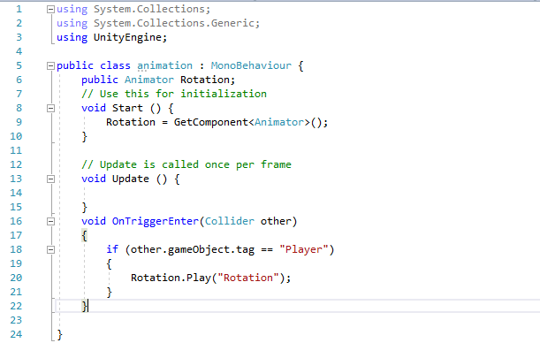

This sets it so when the player tag touches the object the object plays the animation “Rotation”

Allows us to place our animation

This fetches our animation so it can play

1. Save your work then go back into unity. Be sure there are no errors present, now click on your animation object and be sure that “Is trigger” is ticked, otherwise it will not work.
2. You’re finished! Drag the game window so you can operate both the game window and the scene window drag the player object towards the animation object and the animation should start playing.